**Deploy the Application Using the Kubernetes Dashboard**

Project Description:

We will deploy the wordpress application using Kubernetes.

Following tasks are performed as stated below:

1. Getting started with Pods, Services, and Deployments

2. Creating and Verifying the Service

3. Creating a token and working on a dashboard

4. Configure the NFS-server for MySQL and WordPress Deployment

5. Setting up the NFS Client side

6. Creating and verifying the PV

7. Creating a secret for MySQL Deployments secret data

8. Creating a configmap for WordPress Deployment to store non- sensitive information

1. Current Env

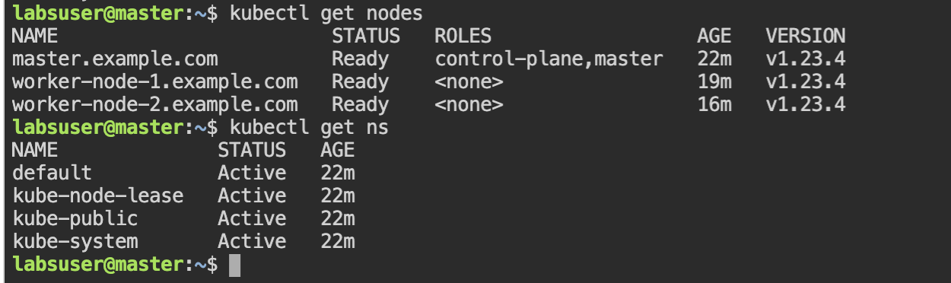

1. Namespace creation for the project and associated resources

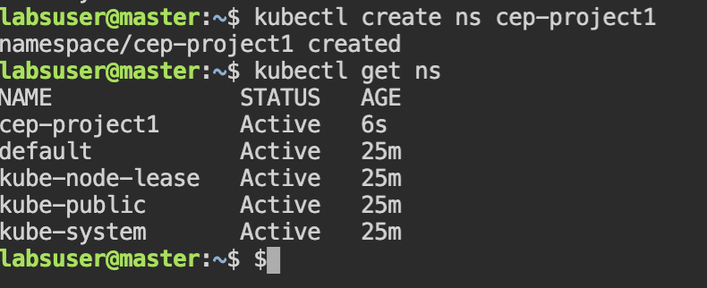

1. Dashboard creation

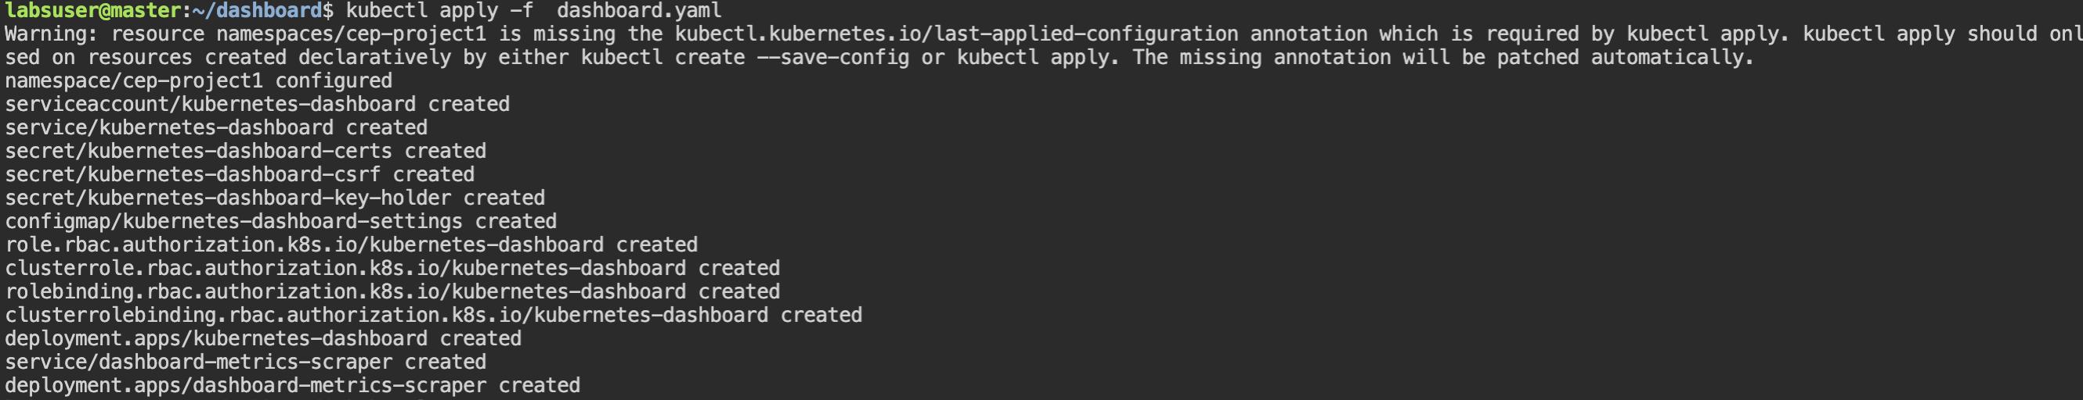

1. Dashboard resources verification

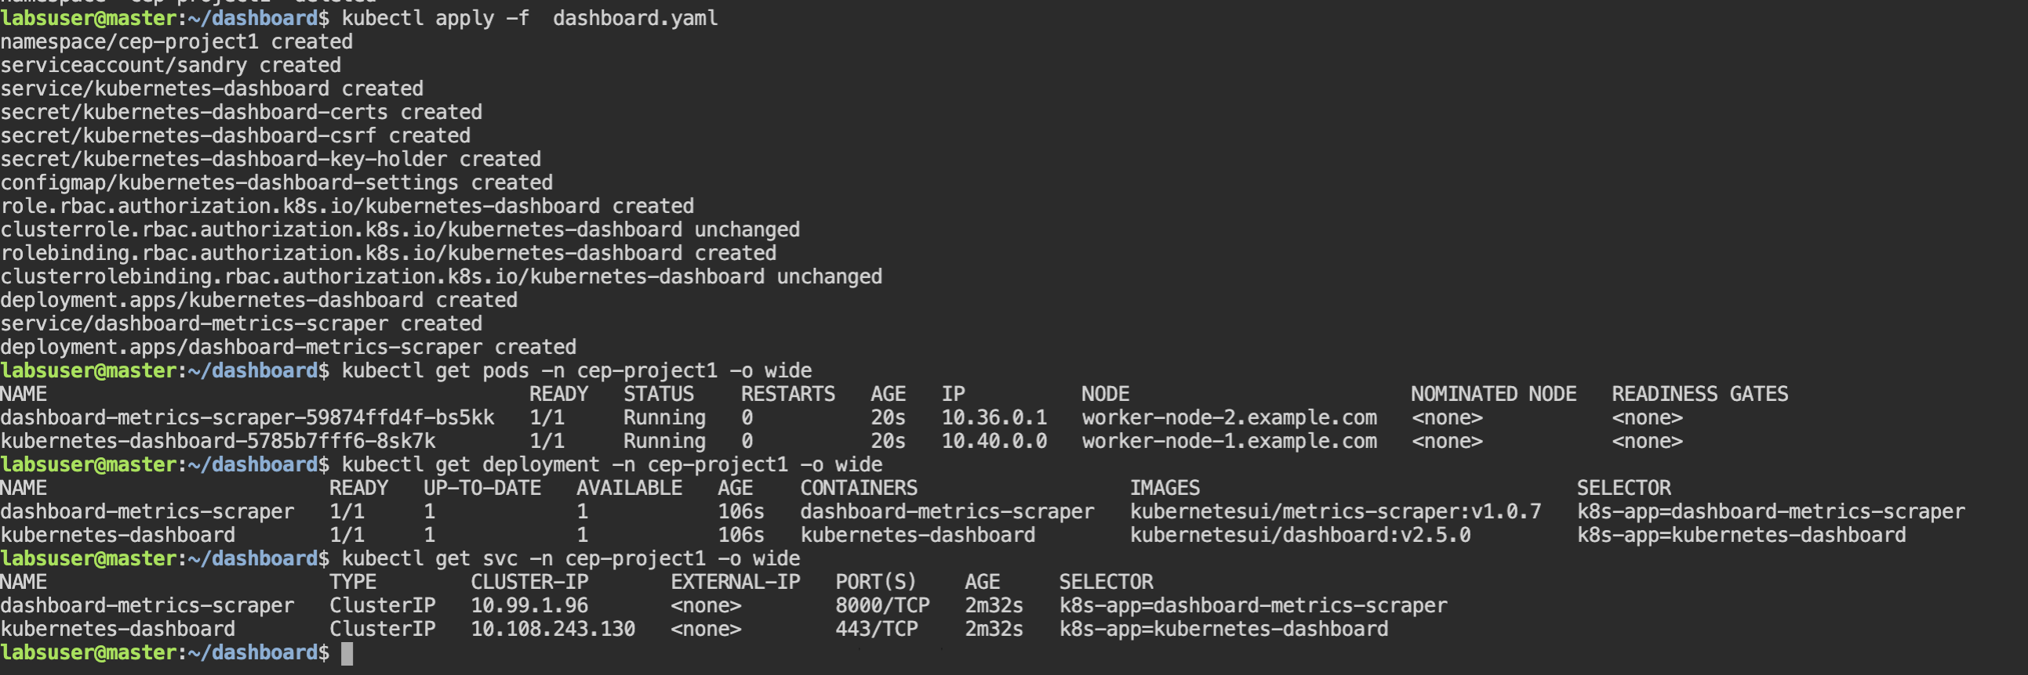

1. Editing the dashboard service type for connection from outside the cluster

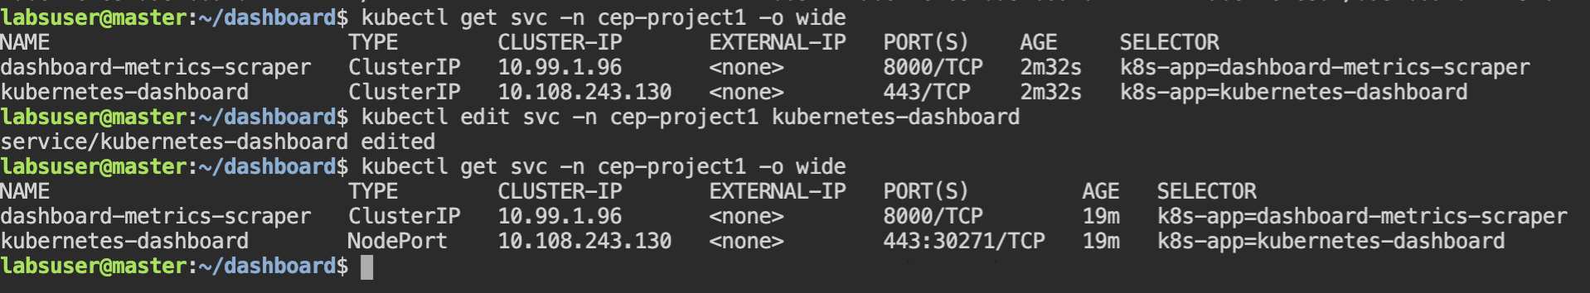

1. Check where the dashboard service is running







1. Form dashboard access link as below

Access the dashboard using the link <https://172.31.48.238:30271>

1. Create a token and access the application

labsuser@master:~/dashboard$ kubectl -n kube-system describe secret $(kubectl -n kube-system get secret | awk '/^deployment-controller-token-/{print $1}') | awk '$1=="token:"{print $2}'

eyJhbGciOiJSUzI1NiIsImtpZCI6InRiUmFYRWhSeG00NV9jRW5JWVBGTG9sZlp6aVlCQnREeHZjZG43d05iVGcifQ..VK9_GHMFa601ZtHKFs5Uq0jyAh2jJYAb2xuusRQrenRBk7JvdyWWJaDkEQjJM-pItGLHeyqiqM05v8u2scjQPV4LfqZF9qKij9_SlPrsqQaM4I0Ax7HtgA8lUK157kaRvfgWsUuwXTsoUkCgqnm5Z6Rx0A0rj-KVzdSf5rjCsPsbgZv93vN6cECoPcaoNzmFYFpWJ12CU05gnhq8s13mboZWEXIxC9tp2aqT881B2SrG2Txb75Khw8npN1R3WjPF2tp2U9J8TNu6S14MhnZ3LSBBbcv4oXsBUhh76pJdy4FK1L_DEytYRnKUKnMkhcUxYN-uSJ3ofB9hrZiHZnqCCA

labsuser@master:~/dashboard$

1. 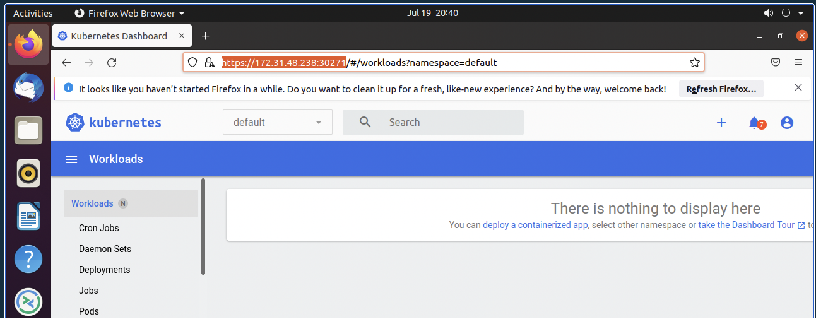
2. Configuring nfs server for mysql wordpress deployment

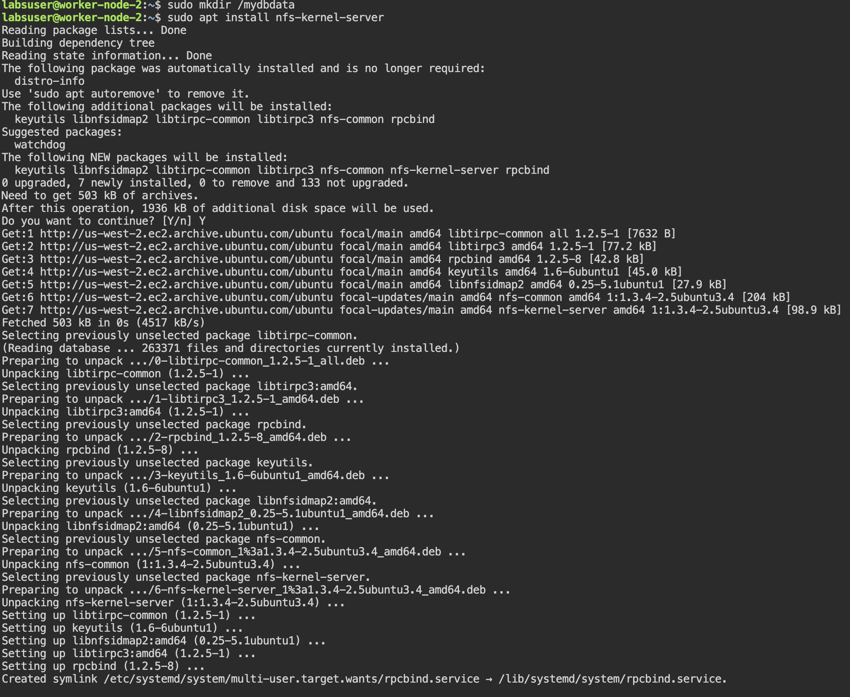

* 1. Continued-Step 10 nfs server deployment

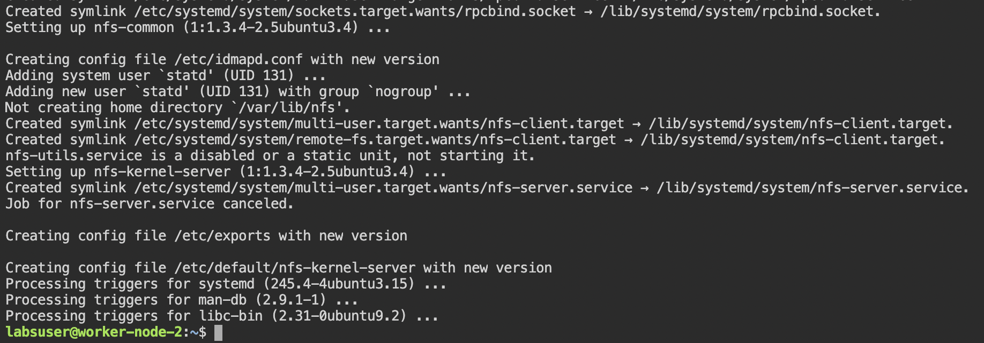

* 1. Add the following lines of code to /etc/exports file and save it

**sudo vi /etc/exports  
/mydbdata *(rw,sync,no_root_squash)**

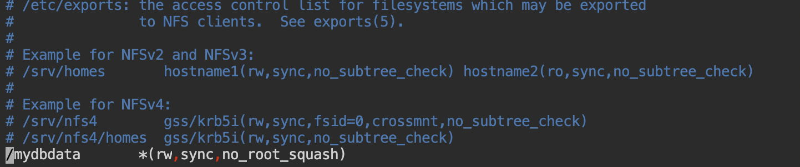

* 1. Use the **exportfs** command to export all shared folders you registered in **/etc/exports** file after making the appropriate changes.

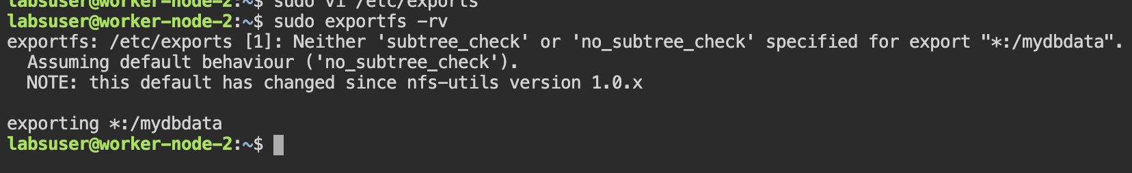

* 1. Change the **owner user** and **group** to **nobody** and **nogroup**.

**sudo chown nobody:nogroup /mydbdata/**

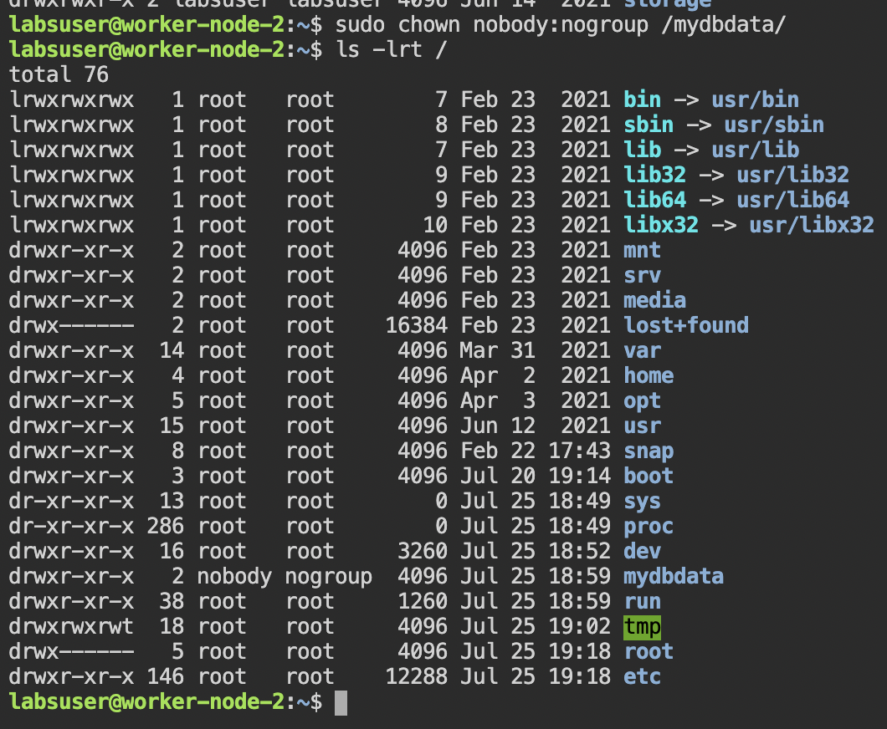

* 1. Set permissions to **777** to allow everyone to read, write, and execute files in this directory (**sudo chmod 777 /mydbdata/)**
  2. Next, restart the **NFS kernel server** to apply the configuration changes.

**sudo systemctl restart nfs-kernel-server**

* 1. Install nfs on master and worker node 1 this is where we intend to share nfs as client.

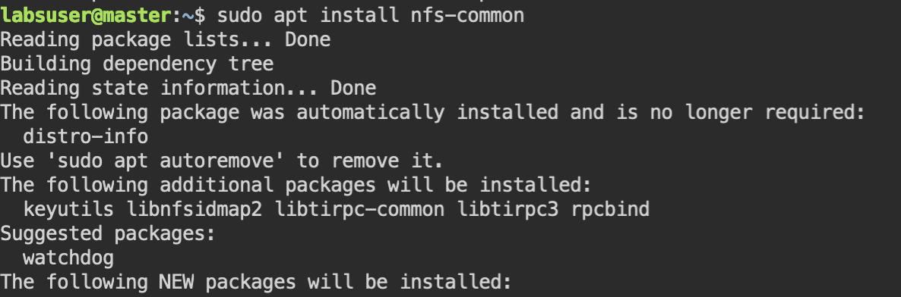

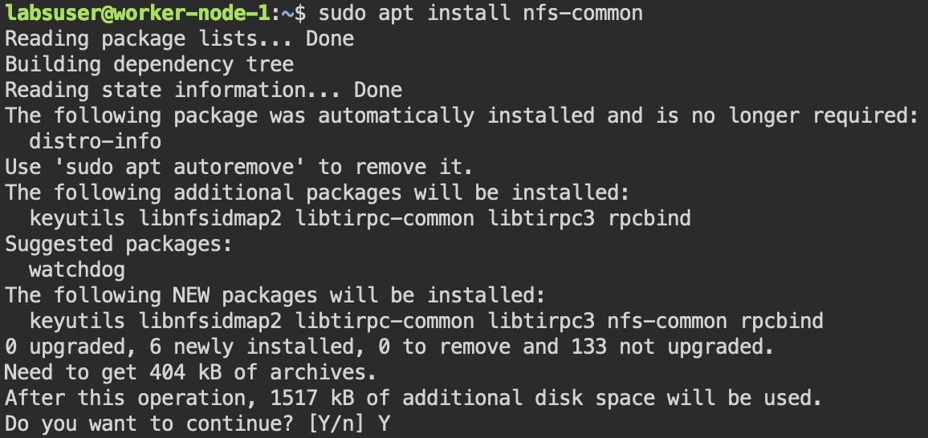

* 1. Create a persistent volume on master node

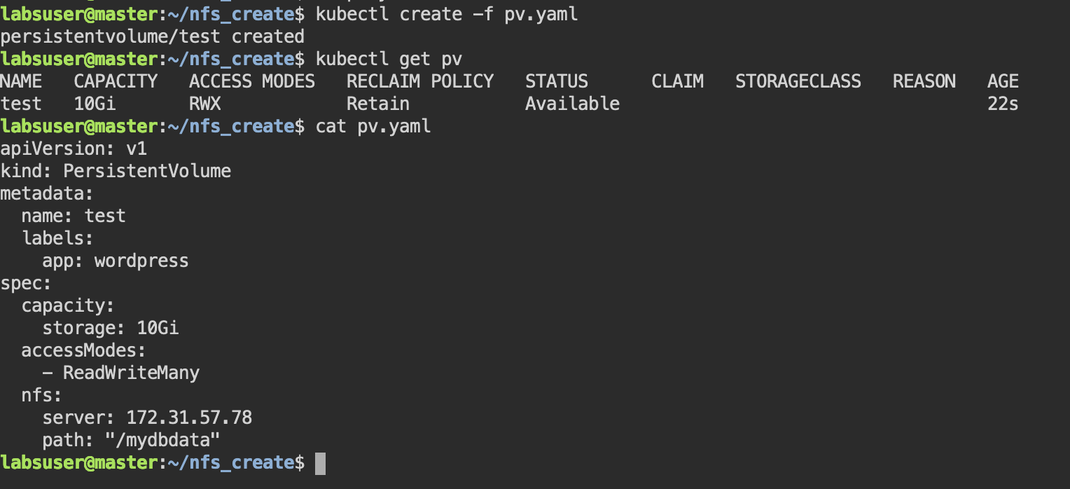

* 1. create a persistent volume claim as shown below

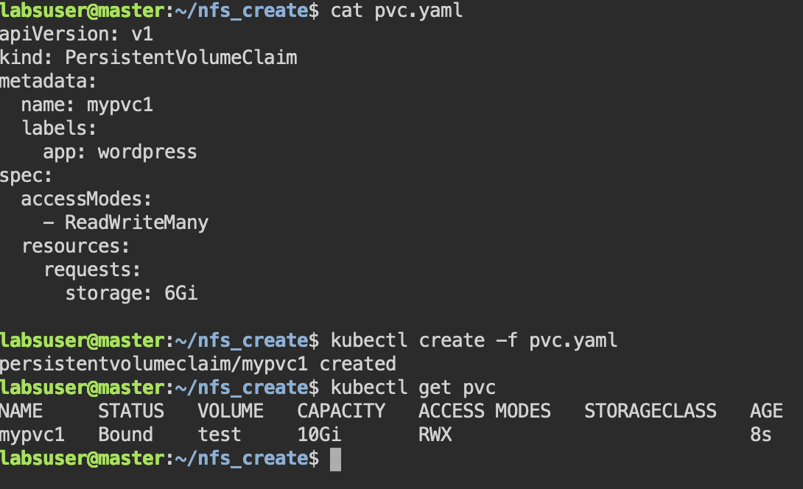

1. Use the manifest below to create a secret,deployment for mysql and wordpress.

Manifests are also available here in my personal git repo.

git@github.com:ankitchanpuria/kubernetes_wordpress.git

****Secret Creation*********

kind: Secret

apiVersion: v1

metadata:

name: project1secret

namespace:cep-project1

stringData:

name_mysql: MYSQL_ROOT_PASSWORD

value_mysql: simplilearn

name_mysqldb: MYSQL_DATABASE

value_mysqldb: database1

name_wdh: WORDPRESS_DB_HOST

value_wdh: mysql

name_wdp: WORDPRESS_DB_PASS

value_wdp: simplilearn

name_wdu: WORDPRESS_DB_USER

value_wdu: root

name_wdn: WORDPRESS_DB_NAME

value_wdn: database1

******Mysql pod creation******

apiVersion: apps/v1

kind: Deployment

metadata:

labels:

app: mysql

name: mysql

namespace: cep-project1

spec:

replicas: 1

selector:

matchLabels:

app: mysql

strategy: {}

template:

metadata:

creationTimestamp: null

labels:

app: mysql

spec:

containers:

- image: mysql:5.6

name: mysql

env:

- name: MYSQL_ROOT_PASSWORD

valueFrom:

secretKeyRef:

name: project1secret

key: value_mysql

optional: false

- name: MYSQL_DATABASE

valueFrom:

secretKeyRef:

name: project1secret

key: value_mysqldb

optional: false

ports:

- containerPort: 3306

name: mysql

volumeMounts:

- name: myvol1

mountPath: /var/lib/mysql

volumes:

- name: myvol1

persistentVolumeClaim:

claimName: mypvc1

*****Wordpress pod creation****

apiVersion: apps/v1

kind: Deployment

metadata:

creationTimestamp: null

labels:

app: wordpress

name: wordpress

namespace: cep-project1

spec:

replicas: 1

selector:

matchLabels:

app: wordpress

strategy: {}

template:

metadata:

creationTimestamp: null

labels:

app: wordpress

spec:

containers:

- image: wordpress

name: wordpress

initContainers:

- name: init-mysqlsvc

image: busybox:1.28

command: ['sh', '-c', "until nslookup mysql.$(cat /var/run/secrets/kubernetes.io/serviceaccount/namespace).svc.cluster.local; do echo waiting for myservice; sleep 2; done"]

env:

- name: WORDPRESS_DB_HOST

valueFrom:

secretKeyRef:

name: project1secret

key: value_wdh

optional: false

- name: WORDPRESS_DB_PASSWORD

valueFrom:

secretKeyRef:

name: project1secret

key: value_wdp

optional: false

- name: WORDPRESS_DB_USER

valueFrom:

secretKeyRef:

name: project1secret

key: value_wdu

optional: false

- name: WORDPRESS_DB_NAME

valueFrom:

secretKeyRef:

name: project1secret

key: value_wdn

optional: false

ports:

- containerPort: 80

name: wordpress

volumeMounts:

- name: myvol1

mountPath: /var/lib/mysql

volumes:

- name: myvol1

persistentVolumeClaim:

claimName: mypvc1

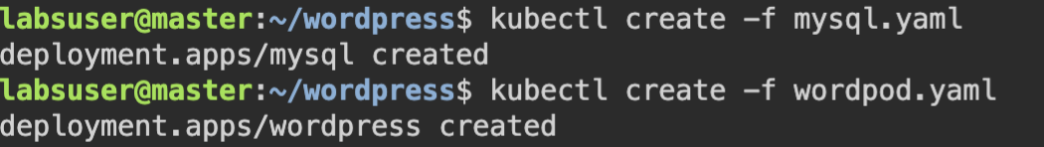

1. Configuration after creation

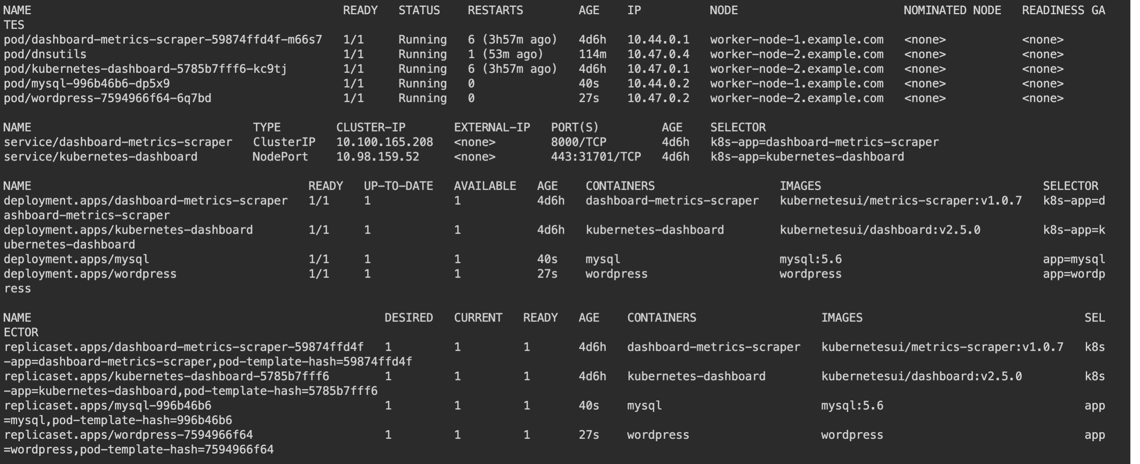

1. Expose services as below



1. Access the website

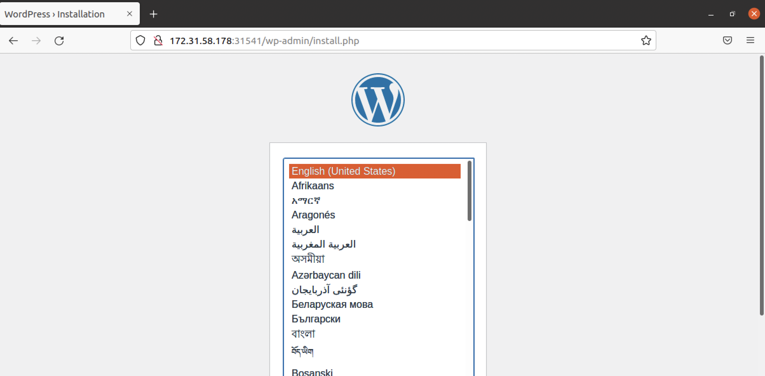

1. All the resources created in namespace cep-project1 shows up in my dashboard

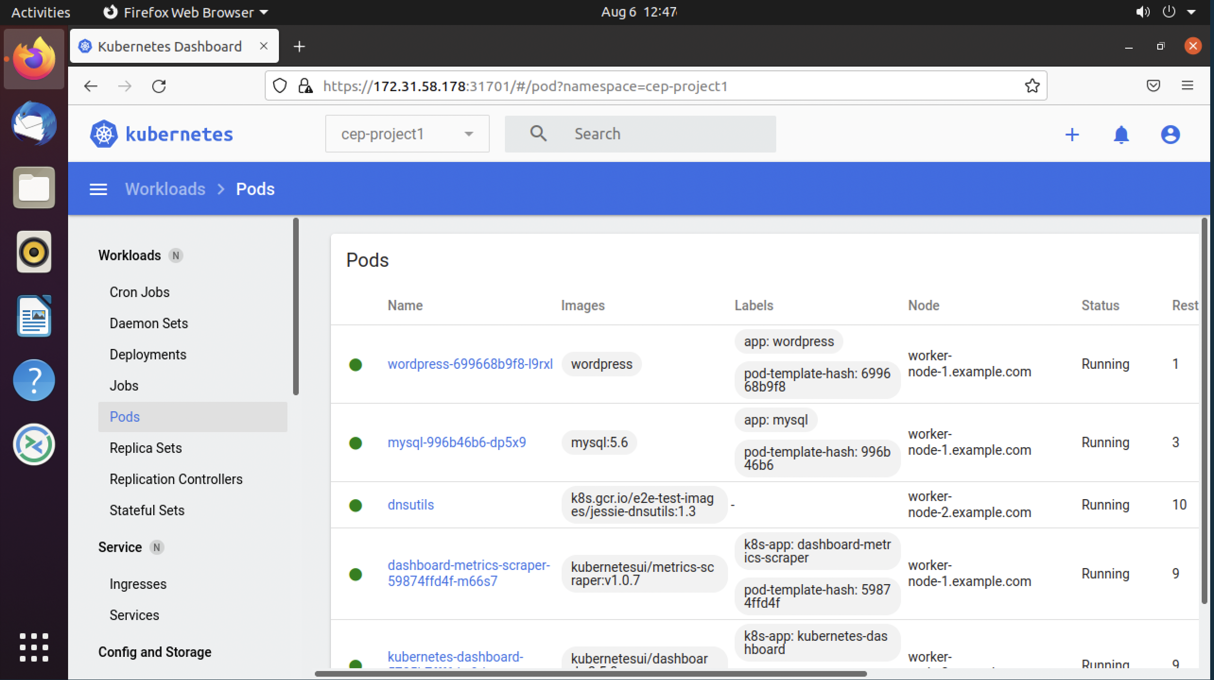

1. Secrets used for the project

